A

TECHNICAL REPORT

OF

STUDENT INDUSTRIAL WORK EXPERIENCE SCHEME(SIWES)

AT

GLOBAL DISTANCE LEARNING INSTITUTE, CENTRAL AREA ABUJA

BY

GANIYU BOLAJI

SUBMITTED TO THE

DEPARTMENT OF COMPUTER SCIENCE FACULTY OF SCIENCE AND TECHNOLOGY,

BINGHAM UNIVERSITY

NASSARAWA STATE

IN PARTIAL FULFILMENT OF THE REQUIMENTS FOR THE AWARD OF BACHELOR OF SCIENCE (B.Sc.)

IN COMPUTER SCIENCE

NOVEMBER, 2022

**CERTIFICATION**

This is to certify that this technical report was written by GANIYU BOLAJI with the Matriculation number of BHU/19/04/05/0092 in the Department of Computer Science, Faculty of Science and Technology, Bingham University, Karu, Nasarawa State, Nigeria.

_______________________________ __________________  
Mrs ADEYEMO OLUWATOYIN

SUPERVISOR DATE

_______________________________ __________________  
DR YAKUBU A. IBRAHIM

DEPARTMENT SIWES DATE

COORDINATOR

_______________________________ __________________  
 DR FAKI SILAS DATE

HEAD OF DEPARTMENT

_______________________________ __________________  
ASSOC.PROF.IHUMA OBO JEROME DATE

SIWES COORDINATOR

DECLARATION

I, GANIYU BOLAJI, hereby declare that this training report is my original work and has not been submitted before for any academic award either in this or other institution. I hereby declare that the SIWES report has been carried out by me with all sources of information acknowledged by means of reference under the supervision of Mrs Oluwatoyin. The references used here from other journals or materials are indicated in the reference section.

Name: GANIYU BOLAJI

Matric: BHU/19/04/05/0092

Signature: _____________________ Date: ________________

DEDICATION

I dedicate this report to God Almighty for his grace, provision and strength all through my SIWES program. This report is also dedicated to my parents, for their love, support, and guidance in my life and career I have chosen.

**ACKNOWLEDGEMENT**

I am grateful to God Almighty for his Grace and mercy during the period of my Industrial attachment successfully.

I’m grateful to all the staff of GDLI for making the time I spent doing my industry training to the interesting educative, and enjoyable.

My sincere appreciation and heartfelt gratitude goes to my industrial based supervisor Mr Simon and my institution based supervisor The HOD Dr Ageebee Faki Silas, Mrs Adeyemo Oluwatoyin, Mr Barka Fori, Ms Anna Bijik Hassan, Mr Jenom Ezekiel Maikori, Dr Onu Egena, Mr Oluwasegun Ishaya Adelaye, Dr Adamu Sulaiman Usman, Mr Joseph Oladele Aremu, Mr Ifeanyi Godwin Elekwa, Mr Musa Yusuf, Mr Okoro Eze Kelechi, Mrs Talatu Boloman, Mrs Ipole Nancy and Departmental SIWES Coordinator Dr Ibrahim Yakubu and all other lecturers of the Department of Computer Science, Faculty of Science and Technology, Bingham University for their contributions to the success and completion of my SIWES training.

**GANIYU BOLAJI**

**Table of Content**

1. Chapter 1: IT Industrial Attachment
   1. Introduction
   2. Purpose
   3. SIWES (STUDENT INDUSTRIAL WORK EXPERIENCE SCHEME)
2. **Chapter 2**: Global Distance Learning Institute
   1. Description of the establishment of attachment
   2. Company’s Staffs
   3. Company’s operation
   4. Company’s Policies
3. **Chapter 3**: My Learning Curve
   1. Industrial Supervisor
   2. Roles of IT Staffs
   3. Tasks Assigned To Me

3.4 Courses taken at the company

**4.0 Chapter 4**: Internship Experience

4.1 Overview of the Internship experience

4.2 Challenges Encountered

4.3 Recommendation

4.4 Ongoing Conclusion

CHAPTER ONE

**IT INDUSTRIAL ATTACHMENT**

**INTRODUCTION:**

Industrial Attachment was introduced to inspire the students with practical and technical skills, as a partial fulfillment for the award of a certificate, Diploma or a Degree and to introduce student into working life.

The training time allows the students to link the theoretical principles learnt in the higher learning institutions and the real life professional and technical application.

It gives the students the practical skills and work environment philosophy, to use their skills and principles learned in class to serve the institutions and the society in general.

Due to above reasons, Bingham University has organized 6 months of training in any institution of students choice to give every student an opportunity to apply the skills and knowledge achieved during the course of study and to acquire new skills in managing relationship and carrying out the jobs assigned.

This is the reason why I joined Global Distance Learning Institute to be trained in order to get practical skills and cut a niche for myself in the communication industry.

**PURPOSE:**

The industrial attachment program fulfils part of the requirement for the award of a Bachelor’s Degree in Computer Science (B.S.c) in Bingham University

This report therefore provides a summary of the activities and duties carried out, as well as experience gained during my attachment period.

**SIWES:**

The Students Industrial Work Experience Scheme (SIWES), is the accepted training programme, which is part of the approved Minimum Academic Standard in the various degree programmes for all Nigerian Universities.  The scheme is aimed at bridging the existing gap between theory and practice of Sciences, Agriculture, Medical Sciences (including Nursing), Engineering and Technology, Management, Information and Communication Technology, and other professional educational programmes in the Nigerian tertiary institutions.  It is aimed at exposing students to machines and equipment, professional work methods, and ways of safeguarding the work areas and workers in industries, offices, laboratories, hospitals, and other organizations.

It is a cooperative industrial internship program that involves institutions of higher learning, industries, the Federal Government of Nigeria, the Industrial Training Fund (ITF), and the Nigerian Universities Commission (NUC).

**CHAPTER TWO**

**GLOBAL DISTANCE LEARNING INSTITUTE**

***Description of the Establishment of Attachment:***

Global Distance Learning Institute also popularly known as **AfriHub** is an educational and ICT center where global education and technological developments are been done.

Global distance learning institute is a child of AFRIHUB and was established in May 2004 to provide human capacity-building technologies, including satellite and wireless internet access, telephony, and US instructor-led technical training to Federal universities throughout Nigeria, as well as to the country’s businesses and government sectors.

The company’s vison statement is to strive to be dynamic, using state-of-the-art technologies for excellence in service delivery, quality and customer values.

The company’s mission statement is to provide the critical combination of infrastructure, service, training, and management required to unleash the power of ICT and Trans-National Education (TNE), leading to globally recognized degree and certifications for human capacity development and economic empowerment

The company provides educational facilities and learning guidelines. AfriHub is located in most of the Nigeria federal schools like UniAbuja, Fut-Mina, and so many more.

The school offers both Foreign and Nigerian diploma for their student based on what they are applying for.

They are also being contracted by both governmental and non-governmental organizations to help build softwares and network for their organization. There are also facility rentals for people who want to use their facility and resource to perform just a little action.

The Companies Services:

1. Academic program (MSC, MBA, BSC)
2. Diploma programs (NID, NCC) as monotechnic
3. Vocational and professional training
4. ICT park development at the Nigeria Tertiary institution
5. CBT and global online exam center
6. ICT services, academic e-portal deployment, and support
7. Edu-portal deployment at the academy
8. Remote work center

Global Distance Learning Institute plays a very vital role in the community with Globally standard educational systems and facility for everyone mostly students. I choose this company because I find its mission to be very relevant to the society and Nigeria at large.

President/CEO

Prof. Manny Aniebonam

General Manager

Vitalis NDU

ABUJA CTR OP

Center Manager(Ag)

Ibrahim Salifu

Finance & Admin

Joy Nnamdi(CFO)

Omoye (Admin mgr)

Institute & GDLI Training Manager (AG)

George Nganya

Facility & Support Service Mgr

Ikenna Amadi

Technology Develop TD level

Toby

Network Support

Network Op lead Simon

Library & Exam Lead (Emeka)

Joy Nnamdi

Omoye Omongbale

Chima Ohaeri

Reginald Ukaonu

Bede Orisa

Ekene Oguchienti

Eugene Onyirimba

Ikenna Amadi

Ishak Haroon

Pius Audu

Blessing Idoga

Gimba John

Emmanuel Kure

Samuel Tom

Professional Training Lead (Odah)

Academic Training Lead (Orakwue)

***Company’s Staff’s:***

Global Distance Learning Institute has staff both in house and scattered all over Nigeria.

The company used to have over 700 hundred staffs before then it got reduced to over 200 Staffs as at 2017.

There are full time staffs and contracted staffs that work in the company both remotely and physically.

The company provides staffs with in house facilities to better aid their work and some Friday’s provide lunch for staffs to fill at home and increase their productivity.

There are different departments in the company and each department has several staffs with one of the staff leading the operation of the department making sure the staff roles for the organization are strictly followed and each staff does their duties as supposed.

In the department of Admin/HR being lead by the HR Miss Linda who makes sure all staffs and facilities are in good condition and state of mind.

The customer care department being lead by Mrs Ogechi, she makes sure customers and clients are well attended to and makes sure customers are being treated fairly.

And not forgetting my own department NOC being lead by Mr Simon who makes sure the networking equipment work as they are supposed to and ensure quality internet connect in the office. And he is also in charge of training the networking students in the company coordinating external examination being ran in the company and so much more.

And the company also has temporary staffs such as the IT student and youth coppers who help in the daily activities of the company to help achieve her goals. Each temporary staff has his/her own department respectfully and obeys the company’s rules to make sure work is efficiently completed.

***Company’s Operation:***

Daily the company trains student and build projects for other organization. From 9am till 12pm there are different courses being taught at different classes by different instructors either virtually or physically then from 12pm till 3pm.

Professional courses are normally held from Mondays – Thursdays.

And each professional course takes place twice a week and at the end they are being issued a certificate of completion.

Each summer they are normally bootcamp for children within the age of 6-17 years to take on courses that improves their knowledge about technology, and trains them on various computer skill like building websites, Graphic design, Python programming, coding for kids, 3D animation and design and computer essential skills such as Microsoft word and the likes.

The company also holds Project Management classes on Saturdays and other vital classes also.

There offer facility rentals to people or organization who would like to use their facility for a short period of time. The rent both class rooms, computers, internet access and software/servers for their use.

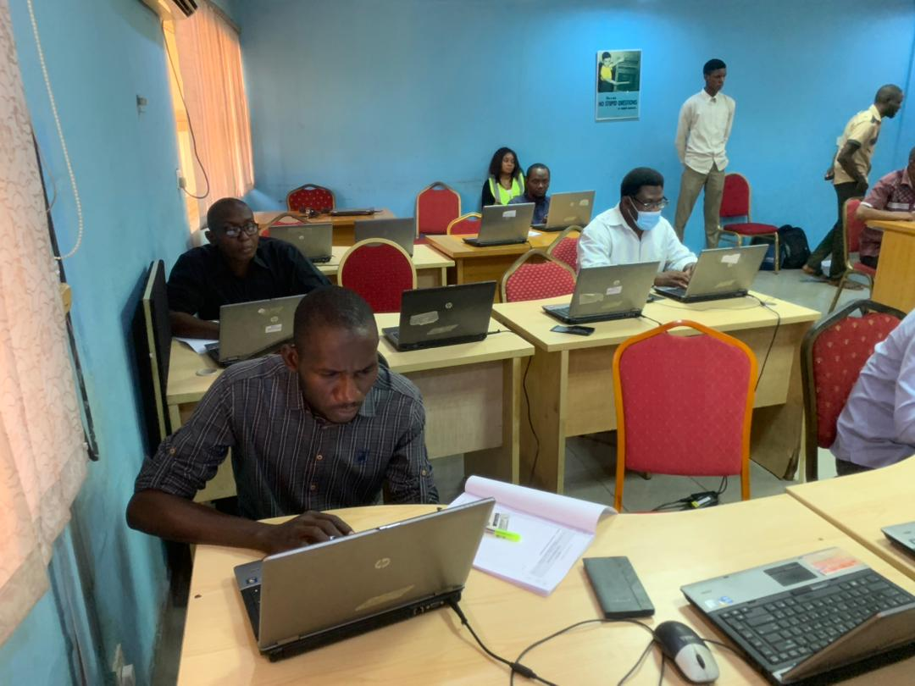

*Figure 1.1: Exam Supervision at Stanford class GDLI*

***Company’s Policies:***

The company has various rules and policies that governs her affairs. As the popular proverbs goes if there’s no rule there’s no sin.

Here are some of the rules staffs of the company lives by:

1. Don’t be late to any meeting
2. Everyone is a marketer
3. Respect all customers
4. Customers are right
5. Don’t be late to work
6. Ensure to sign in and out when using company’s facility
7. Get your work done as at when due
8. Don’t misplace any of the company’s item

And so much more. These are the rules that comes with being an IT staff at their company and there are little or no consequences for breaking this rules.

**CHAPTER THREE**

**MY LEARNING CURVE**

***My Industrial Supervisor:***

My industrial supervisor Mr Simon Ewege the head of the NOC department was in charge of assigning task to the IT students.

He was one of the kindest staffs I know there who always get’s his task done and done on time without any complications or query from the boss. He is in charge of many activities at the company from networking to JAMB an CBT exams from external parties to write exams.

I and four (4) other IT staffs were under his supervision and two (2) youth coppers were also under his supervision and he lead us with the experience of a father and a tech lead. He made sure tasks were being assigned to us and those task were followed through by him till it’s completion.

During any CBT exams he made sure he showed us through on how thing are meant to be done and the connection of each systems to the server and how the server stores the information for retrieval.

He taught use how to ping a network and ensure the flow of packets in the networking devices such as the switches had no loop and all the systems could get the server.

He taught us the wireless means of connecting to the servers and the wired process and also how to fix the hardware device having issues, autoboot software and how to format/reboot a system with little faults.

He made sure we all came to work and that we all attend each meeting in our NOC department. Whenever the work seems much he made sure he encouraged us and get other hands to ensure the smooth flow of the work.

Never the less he corrected us whenever the corrections were needed and ensured that we were treated well in the organization.

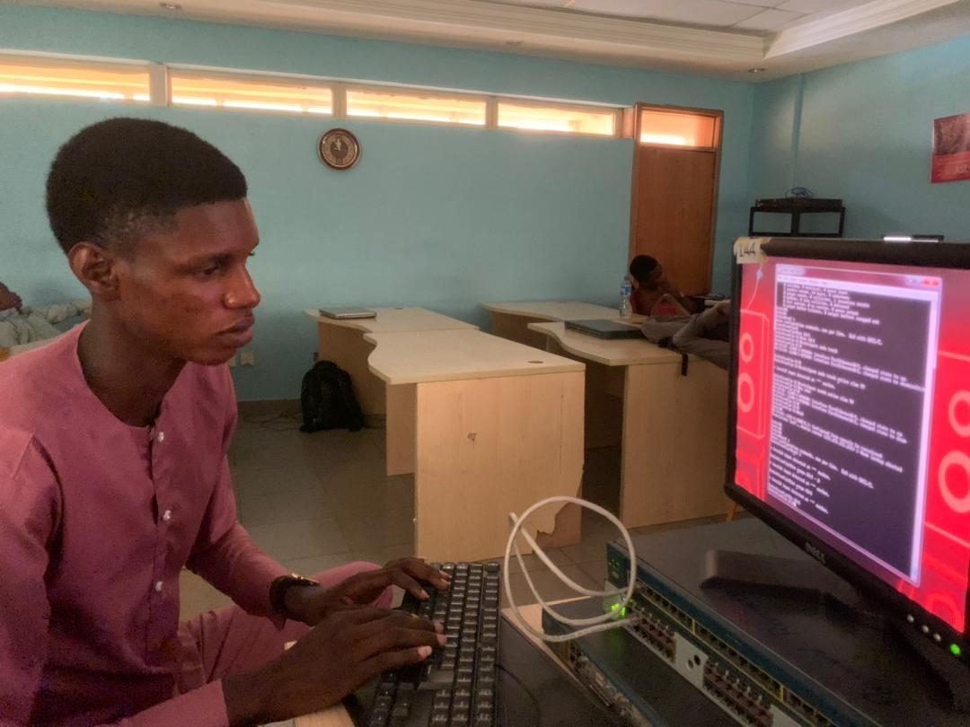

*Figure 1.2: Configuring a Router and a Switch for a VLAN network*

***My Role In the Company:***

My role just like the other interns of the company was to make sure I came to work daily, complete my task for the day and learn something new.

I was assigned to the NOC department at my first point of entering the organization then with time I started visiting other departments of the company and was assign some tasks to carry out in each of the various departments I visited and still was a core member of the NOC department.

I visited the development department were they focused mainly on software development and they also trainer student, staffs, and interns on how to build projects, deploy project, manage them and keep them secure. On Tuesdays and Thursdays I attend the cyber security classes where I learnt so much attacks a threat actors can use to get confidential information from one’s system or organization and use for their malicious use. How you need to defend your system from those threat actors. I understood the teams used in the cyber security world terms such as Asset, Vulnerability, Confidentiality and so much more.

I learnt the CIA (Confidentiality, Integrity and Authorization) in the world of cyber security even though I didn’t pay for the course and I wasn’t meant to attend it.

I worked in the marketing department were I and the others formed strategies to use to get more clients and customers. We use various marketing strategies and mediums to get clients and customers. Some of the mediums and strategies we deployed were Social media, streaming videos, referrers, and traditional marketing. We had open house where prospective clients and customers came to know about what we do as a company and how we intend to improve their ways of doing things with our technological softwares and how we can improve their knowledge about what they already know and what this world has to offer them.

We went on traditional marketing where we met with people physically to talk to them about what we do as an organization. We made videos showing the activities of the organization and so much more.

We helped arrange systems in the company for use and exams.

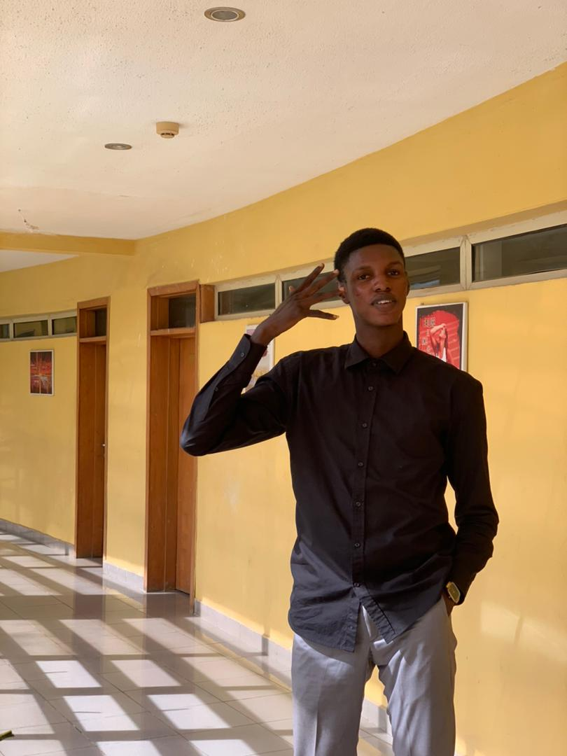

*Figure 1.3: The Atmosphere of the office*

***Tasks Assigned To Me:***

I was assigned several tasks to complete.

During classes, events, or exams I and my fellow IT staff made sure things in the hall, and class we properly organized and worked as they should.

Mr. Simon my IT supervisor made sure we were assigned tasks on a regular base. We set up systems for exams and made sure the systems connection to the servers are always properly established and all the systems are always ready for exams. We use Routers and Switches to configure and WLAN to configure for the organization and other organizations that need our help.

Mr. Tolu and Madam Chisom in the development department regularly gave tasks like a section of software to be built.

I and Mr Clinton the head of marketing alongside Mr Chris a youth copper made sure we conducted the marketing affairs

***Courses I Took:***

I took a CCNA course where I learn about networking devices and their configuration. How to build LANs, VLANs, MANs and WLANs and we went a bit into building WANs understanding NAT and PAT.

I did some online courses on React Native and Backend Technology while doing my IT.

I built a Voting app we were supposed to use in school for the electoral process but didn’t later use. Built a chat-app full fleche front end in React Native with smooth navigations a restaurant application and so much more.

I built both mobile and web apps that I don’t remember cause I was just practicing.

***My Teaching Experience:***

I was asked to teach the web development class then I was switched to teach the python class where I taught them python programming.

The Bootcamp was a six (6) week Bootcamp where student from different schools came to learn python programming, web design, coding for kids, mobile development, graphic design, 3D animation, and computer essentials.

I and an IT staff were in charge of the python class where we taught them the following:

* Variables
* Data Types
* List, Tuples, Set, and Dictionary
* Conditional statements
* Loops (for loops and while loops)
* Functions
* OOP in python
* File handling in python

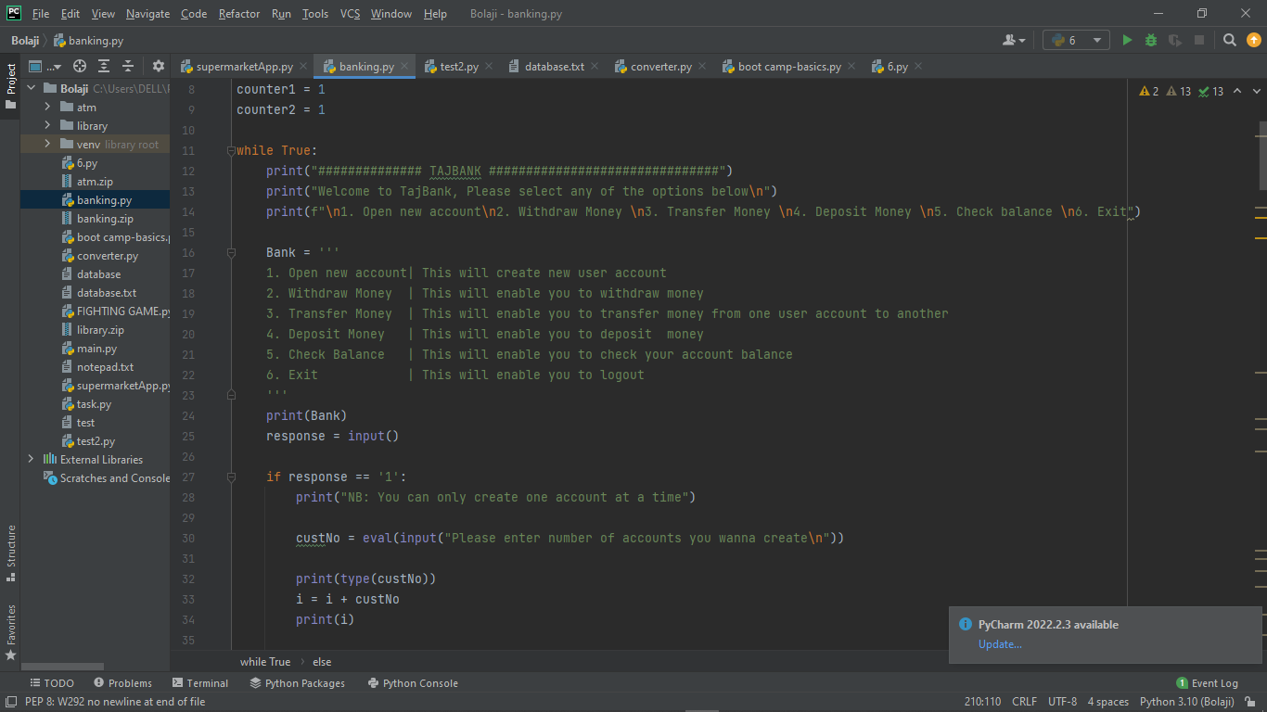

*Figure 1.4: Python programming*

It was one of the best experiences for me and my colleague Matthew to teach what we just learned to students so they can understand.

The classes were held on Mondays – Thursdays from 9 am -12 pm.

After the class we went back to doing the other tasks given to us by our supervisors.

***Skills I Developed:***

During my internship program with AfriHub, I developed skills from the company, personal and self taught skills.

During the internship program, I was opportune to learn the following skills

* CCNA Networking Devices
* Marketing Skills
* Programming Skills
* Software Development Skills(Both web and Mobile)
* Communication Skills
* Customer Service Skills
* Team Spirit

Moving to places, being given tasks and personal study were the reasons for the development of these skills

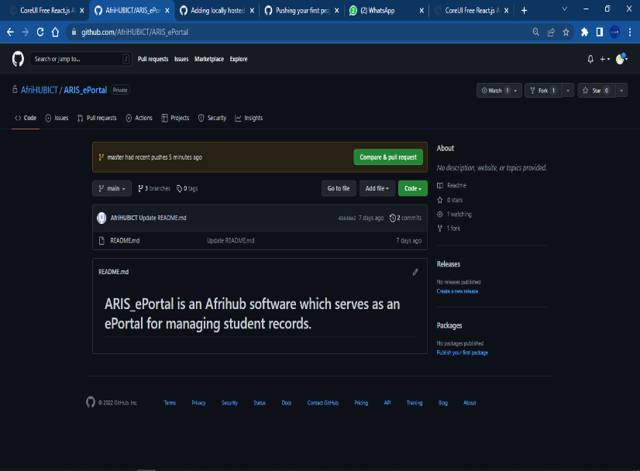

*Figure 1.5: Git and Github workspace*

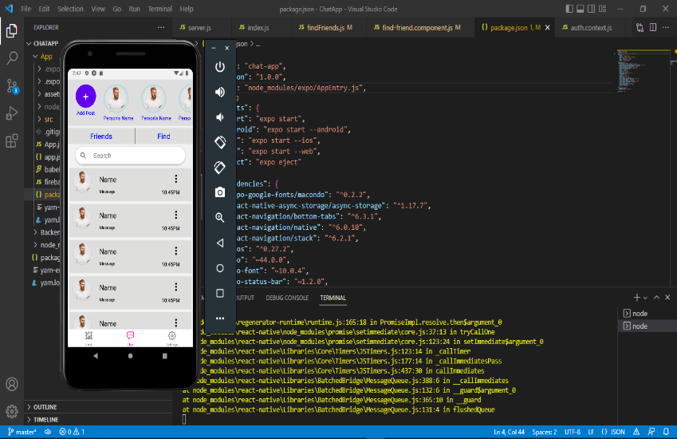

*Figure 1.6: Android studio and Mobile Development*

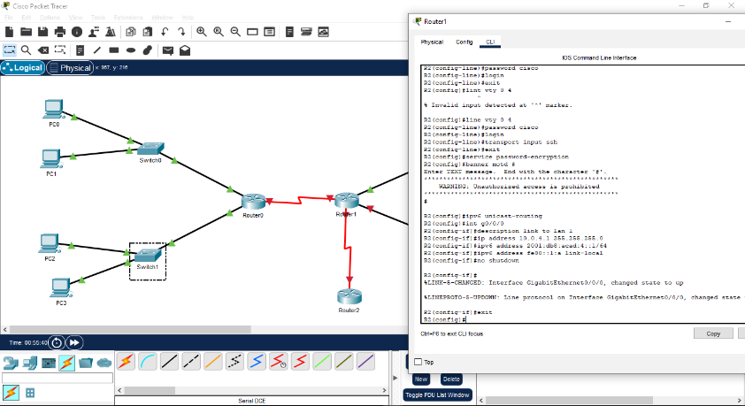

*Figure 1.7: CCNA simulation practical*

CHAPTER FOUR

Internship Experience

***Overview of the Internship Experience:***

During my experience with Global Distance Learning Institute also known as AfriHub, I was able to develop my software development and Tech skills. I particularly found software development useful in improving my Technical skills. Although I found Software development, Networking, and other skills to be challenging, I found it to be valuable in developing my Software development and Networking Skill.

***Challenges Encountered:***

* Daily Hold up on the way to work
* No break time

***Recommendations:***

* Professional and project development
* Well Structured and functional management
* Skill acquisition and career building

***Ongoing Consideration:***

While I had many useful experience at Global Distance Learning Institute, I feel that I still need to develop my confidence levels with So many tasks. I would have enjoyed more time completing my tasks.

**Conclusion:**

The IT journey was an experience not to be ever forgotten not just for the skills I acquired but for the hands on experience on the devices and the development of the software I made will in the company.

Reference:

* <https://www.wikihow.com/Write-an-IT-Report>
* Afodiya, Mr Simon and Mrs Chisom
* <https://www.indeed.com/career-advice/career-development/how-to-write-an-internship-report>
* <https://www.afrihub.com/>